Lab 10
Lesson 11-2: Record Data Type
Exercise 1:

const int FEET_IN_YARDS = 3;
const int YARDS_IN_MILES = 1760;

struct Distance
{
long feet;
long yards;
long miles;
};

Distance AddDistance(Distance, Distance);
Distance ConvertYards(long);
Distance ConvertFeet(long);
void PrintDistance(Distance, Distance, Distance);

//********* Distance Operations ********************

Distance AddDistance
(Distance distance1, Distance distance2)
// Pre: distance1 and distance2 contain valid data.
// Post: Returns distance1 + distance2.
{
Distance combDistance;
combDistance.feet = distance1.feet + distance2.feet;
combDistance.yards = distance1.yards + distance2.yards;
combDistance.miles = distance1.miles + distance2.miles;

if (combDistance.feet > 3)
{
combDistance.feet = combDistance.feet - 3;
combDistance.yards = combDistance.yards + 1;
}
if (combDistance.yards > 1760)
{
combDistance.yards = combDistance.yards - 1760;
combDistance.miles = combDistance.miles + 1;
}

return (combDistance);
}

//******************************************************

Distance ConvertYards(long yards)
// Post: yards has been converted into a variable of
// Distance.
{
Distance convertYards;
convertYards.feet = 0;
convertYards.yards = (yards % YARDS_IN_MILES);
convertYards.miles = (yards / YARDS_IN_MILES);

return (convertYards);

}
//******************************************************

Distance ConvertFeet(long feet)
// Post: feet has been converted into a variable of
// Distance.
{
Distance convertFeet;
convertFeet.feet = (feet % FEET_IN_YARDS);
convertFeet.yards = ((feet / FEET_IN_YARDS) % YARDS_IN_MILES);
convertFeet.miles = ((feet/ FEET_IN_YARDS) / YARDS_IN_MILES);

return (convertFeet);
}

//******************************************************

void PrintDistance(Distance combDistance, Distance convertYards, Distance convertFeet)
// Post: A vriable of Distance is printed as as feet,
// yards, and miles.
{
cout << "Distance of Distance1 + Distance2 is " << endl
<< "Feet: " << combDistance.feet
<< " Yards: " << combDistance.yards
<< " Miles: " << combDistance.miles << endl;
cout << "Distance is " << endl << "Feet: " << convertFeet.feet
<< " Yards: " << convertFeet.yards
<< " Miles: " << convertFeet.miles << endl;
cout << "Distance is " << endl << "Feet: " << convertYards.feet
<< " Yards: " << convertYards.yards
<< " Miles: " << convertYards.miles << endl;
}

Exercise 2:

#include <iostream>

using namespace std;

const int FEET_IN_YARDS = 3;
const int YARDS_IN_MILES = 1760;

struct Distance
{
long feet;
long yards;
long miles;
};

Distance AddDistance(Distance, Distance);
Distance ConvertYards(long);
Distance ConvertFeet(long);
void PrintDistance(Distance, Distance, Distance);

int main()
{
Distance distance1 = {2, 1750, 2};
Distance distance2 = {2, 10, 0};
long feet = 6002;
long yards = 5230;

Distance combDistance = AddDistance (distance1, distance2);
Distance convertYards = ConvertYards( yards);
Distance convertFeet = ConvertFeet ( feet);

PrintDistance (combDistance, convertYards, convertFeet);

system("PAUSE");
return 0;
}
//********* Distance Operations ********************

Distance AddDistance
(Distance distance1, Distance distance2)
// Pre: distance1 and distance2 contain valid data.
// Post: Returns distance1 + distance2.
{
Distance combDistance;
combDistance.feet = distance1.feet + distance2.feet;
combDistance.yards = distance1.yards + distance2.yards;
combDistance.miles = distance1.miles + distance2.miles;

if (combDistance.feet > 3)
{
combDistance.feet = combDistance.feet - 3;
combDistance.yards = combDistance.yards + 1;
}
if (combDistance.yards > 1760)
{
combDistance.yards = combDistance.yards - 1760;
combDistance.miles = combDistance.miles + 1;
}

return (combDistance);
}

//******************************************************

Distance ConvertYards(long yards)
// Post: yards has been converted into a variable of
// Distance.
{
Distance convertYards;
convertYards.feet = 0;
convertYards.yards = (yards % YARDS_IN_MILES);
convertYards.miles = (yards / YARDS_IN_MILES);

return (convertYards);

}
//******************************************************

Distance ConvertFeet(long feet)
// Post: feet has been converted into a variable of
// Distance.
{
Distance convertFeet;
convertFeet.feet = (feet % FEET_IN_YARDS);
convertFeet.yards = ((feet / FEET_IN_YARDS) % YARDS_IN_MILES);
convertFeet.miles = ((feet/ FEET_IN_YARDS) / YARDS_IN_MILES);

return (convertFeet);
}

//******************************************************

void PrintDistance(Distance combDistance, Distance convertYards, Distance convertFeet)
// Post: A vriable of Distance is printed as as feet,
// yards, and miles.
{
cout << "Distance of Distance1 + Distance2 is " << endl
<< "Feet: " << combDistance.feet
<< ", Yards: " << combDistance.yards
<< ", Miles: " << combDistance.miles << endl << endl;
cout << "Feet conversion of distance is " << endl
<< "Feet: " << convertFeet.feet
<< ", Yards: " << convertFeet.yards
<< ", Miles: " << convertFeet.miles << endl << endl;
cout << "Yard conversion of distance is " << endl
<< "Feet: " << convertYards.feet
<< ", Yards: " << convertYards.yards
<< ", Miles: " << convertYards.miles << endl << endl;
}

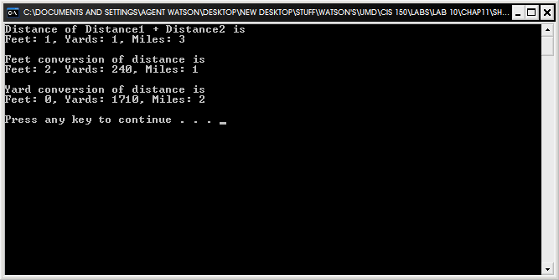
Exercise 3:

#include <iostream>

using namespace std;

const int FEET_IN_YARDS = 3;
const int YARDS_IN_MILES = 1760;

struct Distance
{
float feet;
float yards;
float miles;
};

Distance AddDistance(Distance, Distance, Distance);
Distance ConvertYards(long);
Distance ConvertFeet(long);
void PrintDistance(Distance, Distance, Distance, float);
float MilesPerHour (Distance, long);
int main()
{
Distance distance1;
Distance distance2;
Distance distance3 = {0, 0, 37};
long feet = 15000;
long yards = 12000;
long time = 45;
float MPH;

distance1 = ConvertYards( yards);
distance2 = ConvertFeet ( feet);
Distance combDistance = AddDistance (distance1, distance2, distance3);
MPH = MilesPerHour(combDistance, time);

PrintDistance (combDistance, distance1, distance2, MPH);

system("PAUSE");
return 0;
}
//********* Distance Operations ********************

Distance AddDistance
(Distance distance1, Distance distance2, Distance distance3)
// Pre: distance1 and distance2 contain valid data.
// Post: Returns distance1 + distance2.
{
Distance combDistance;
combDistance.feet = distance1.feet + distance2.feet + distance3.feet;
combDistance.yards = distance1.yards + distance2.yards + distance3.yards;
combDistance.miles = distance1.miles + distance2.miles + distance3.miles;

if (combDistance.feet > 3)
{
combDistance.feet = combDistance.feet - 3;
combDistance.yards = combDistance.yards + 1;
}
if (combDistance.yards > 1760)
{
combDistance.yards = combDistance.yards - 1760;
combDistance.miles = combDistance.miles + 1;
}

return (combDistance);
}

//******************************************************

Distance ConvertYards(long yards)
// Post: yards has been converted into a variable of
// Distance.
{
Distance convertYards;
convertYards.feet = 0;
convertYards.yards = (yards % YARDS_IN_MILES);
convertYards.miles = (yards / YARDS_IN_MILES);

return (convertYards);

}
//******************************************************

Distance ConvertFeet(long feet)
// Post: feet has been converted into a variable of
// Distance.
{
Distance convertFeet;
convertFeet.feet = (feet % FEET_IN_YARDS);
convertFeet.yards = ((feet / FEET_IN_YARDS) % YARDS_IN_MILES);
convertFeet.miles = ((feet/ FEET_IN_YARDS) / YARDS_IN_MILES);

return (convertFeet);
}

//******************************************************
float MilesPerHour (Distance combDistance, long time)
{
float mph1;
float mph2;
float mph3;
float totalMPH;

mph1 = ((combDistance.feet / FEET_IN_YARDS) / YARDS_IN_MILES) / time * 60.0;
mph2 = (combDistance.yards/YARDS_IN_MILES) / time * 60.0;
mph3 = (combDistance.miles/ time) * 60.0;
totalMPH = mph1 + mph2 + mph3;
return (totalMPH);
}

void PrintDistance(Distance combDistance, Distance distance1, Distance distance2, float MPH)
// Post: A vriable of Distance is printed as as feet,
// yards, and miles.
{
cout << "Distance of Distance1 + Distance2 is " << endl
<< "Feet: " << combDistance.feet
<< ", Yards: " << combDistance.yards
<< ", Miles: " << combDistance.miles << endl << endl;
cout << "Feet conversion of distance is " << endl
<< "Feet: " << distance1.feet
<< ", Yards: " << distance1.yards
<< ", Miles: " << distance1.miles << endl << endl;
cout << "Yard conversion of distance is " << endl
<< "Feet: " << distance2.feet
<< ", Yards: " << distance2.yards
<< ", Miles: " << distance2.miles << endl << endl;
cout << "Miles Per Hour Traveled is " << MPH << endl << endl;
}

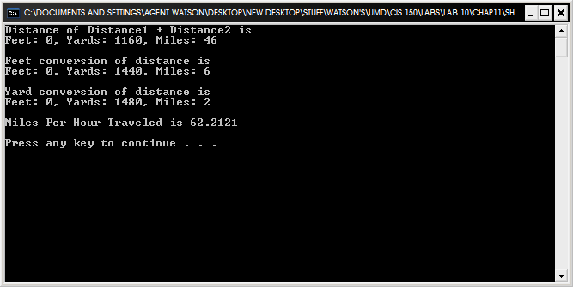
Lesson 11-3: Hierarchical Records

Exercise 2:

// Program Cars reads a record from a file and writes
// its contents back to another file with the price member
// increased by 10%.
#include <iostream>
#include <fstream>
#include <string>
using namespace std;

struct Date
{
int month;
int day;
int year;
};

struct Car
{
float price;
Date purchased;
string customer;
bool sold;
Date soldDate;
string soldTo;
};

void GetCar(ifstream&, Car&);// Reads a variable of Car from a file.
void CarSold(Date , Car&);
void WriteSold(ofstream&, Car);
void WriteCar(ofstream&, Car);// Writes a variable of Car on a file.

int main ()
{
int sellDate;
int sellMonth;
int sellYear;
string response;
Car car;
Date sellDat;
ifstream dataIn;
ofstream dataOut;
ofstream dataSold;

dataIn.open("cars.dat");
dataOut.open("cars.out");
dataSold.open("carsSold.txt");

dataOut << fixed << showpoint;
GetCar(dataIn, car);
while (!dataIn.eof())
{
car.price = car.price * 1.10;
FirstQuestion: cout << endl //Label FirstQuestion
<< "Customer: " << car.customer
<<"\nHas the vehicle been resold? Yes or No.\n";
cin >> response;
response = response.substr(0,1);

if (response == "Y" || response == "y")
{
cout <<"What day did you resell the car on (DD)?" << endl;
cin >> sellDate;
sellDat.day = sellDate;
cout << "What month did you resell the car in (MM)?" << endl;
cin >> sellMonth;
sellDat.month = sellMonth;
cout << "What year did you resell the car in (YYYY)?" << endl;
cin >> sellYear;
sellDat.year = sellYear;
cout << "Who did you sell it to?" << endl;
cin >> response;
car.soldTo = response;
CarSold(sellDat , car);
WriteSold(dataSold, car);
}
else if (response == "N" || response == "n")
{
WriteCar(dataOut, car);
}

else
{
cout << "Sorry, there was some incorrect input. Please retry. \n\n";
cin.get();
goto FirstQuestion;
}

GetCar(dataIn, car);

}

dataOut.close();
dataSold.close();

system ("PAUSE");
return 0;

}

//*****************************************************

void GetCar(ifstream& dataIn, Car& car)
// Pre: File dataIn has been opened.
// Post: The fields of car are read from file dataIn.
{
car.sold = false;
dataIn >> car.customer
>> car.price >> car.purchased.day
>> car.purchased.month >> car.purchased.year;
dataIn.ignore(2, '\n');
return;
}

//*****************************************************

void WriteCar(ofstream& dataOut, Car car)
// Pre: File dataOut has been opened.
// Post: The fields of car are written on file dataOut,
// appropriately labeled.
{
dataOut << "Customer: " << car.customer << endl
<< "Price: " << car.price << endl
<< "Purchased:" << car.purchased.day << "/"
<< car.purchased.month << "/"
<< car.purchased.year << endl;
}

//*********************************************************==old: "
void CarSold(Date sellDat , Car& car)
{
car.sold = true;
car.soldDate.day = sellDat.day;
car.soldDate.month = sellDat.month;
car.soldDate.year = sellDat.year;
}
void WriteSold(ofstream& dataSold, Car car)
{
dataSold << "Customer: " << car.customer << endl
<< "Price: " << car.price << endl
<< "Purchased:" << car.purchased.day << "/"
<< car.purchased.month << "/"
<< car.purchased.year << " Sold Date: " << car.soldDate.day<< "/"
<< car.soldDate.month << "/"
<< car.soldDate.year << endl
<< "Sold to: " << car.soldTo << endl << endl;
}
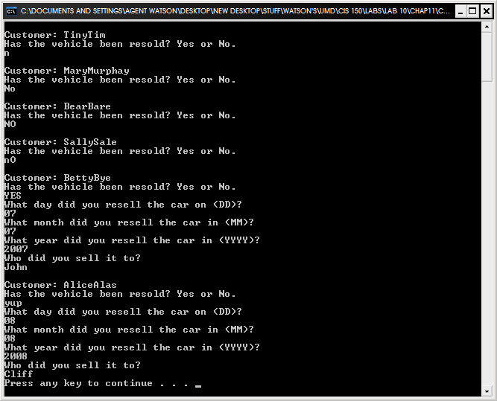
Included output files found in compressed folder: cars.out and carsSold.txt

